**Network Programming Lab NS3 Programs Execution Steps**

step 1.)

Login into sudo su

type the password:



Step 2.) Change your directory to ns3

cd ns-allinone-3.30.1/ns-3.30.1



Step 3.) Change your directory to scratch

cd scratch/



Step 4.)Create your file with .cc extension

gedit filename.cc

step 5.) change your directory.

cd ..

Step 6.) compile the file with waf

./waf

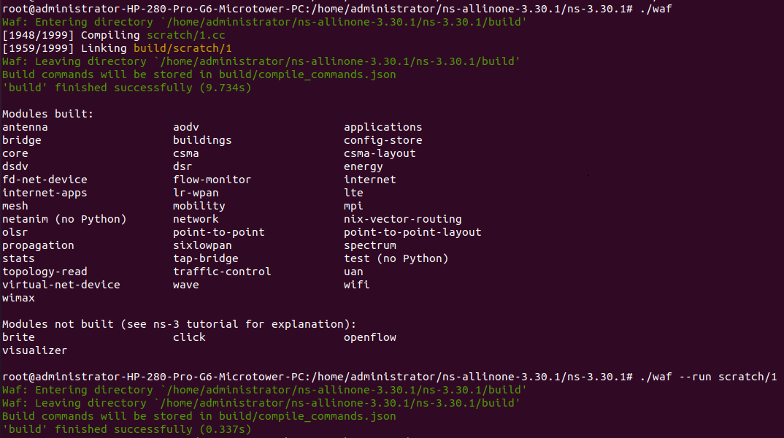

step 7.) execute the file

./waf --run scratch/filename without extension

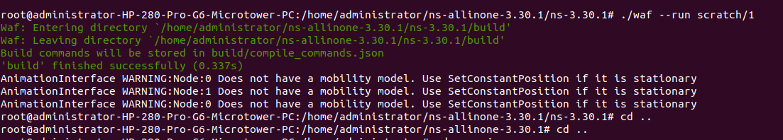

step 8.) execute netanimation

cd ..

step 9.) Change your directoy to neanimation

cd netanim-3.108/

step 10.)enable netanimation

export QT_X11_NO_MITSHM=1

search .xml file and open

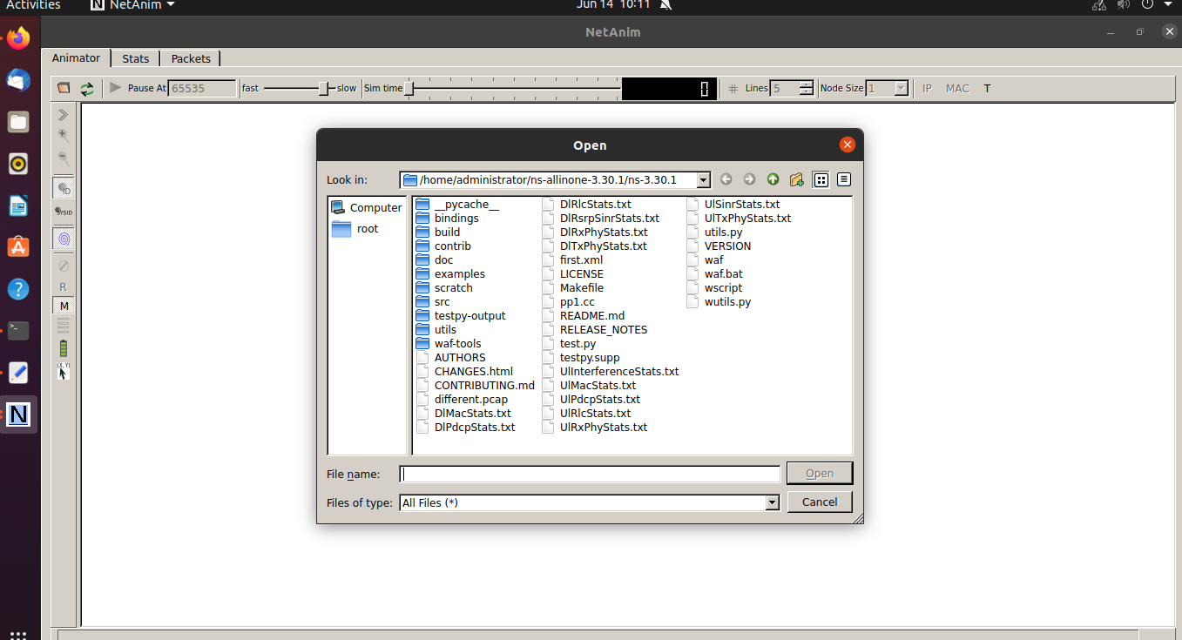

step 11.) execute

./NetAnim

